SIMATS ENGINEERING
ASSESSMENT TOOL 2

COURSE NAME: Artificial Intelligence COURSE CODE: CSA17
NAME:Gayathri.P
REG NO:192424324

COURSE OUTCOME COVERED

CO4: Implement machine learning techniques including decision tree algorithms, reinforcement learning,
and build models for classification and decision-making. (BL3)

Assessment Tool Weightage: 10%

Duration : 1 hour

QUESTIONS: 4 Total Marks:40

Annexure A

ARTICLE REVIEW

Code of Conduct:

I ___Gayathri.P(192424324)_ (Name / Reg No) certify that this submission is my original work and that I have adhered
to the guidelines specified for this assessment.
I understand that any violation of academic integrity rules will result in disciplinary action.

Signature of the student:
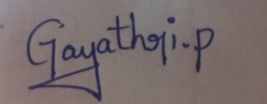

Annexure A

ARTICLE REVIEW

INSTRUCTIONS
Select any ONE peer-reviewed research article (published after 2019) from IEEE Xplore, Springer, Elsevier, or ACM Digital Library related to any of the following topics: Inductive Learning, Decision Trees, Statistical Learning Methods (Naïve Bayes / Logistic Regression / SVM), or Reinforcement Learning applications.
Submit: (i) Article citation details (ii) PDF or valid DOI link (iii) Written review as per the tasks below.

Task 1: Article Summary
(a) Provide the full citation of the article (Author(s), Title, Journal/Conference, Year, DOI). State the domain/application area and the specific ML problem addressed.
(b) Summarise the key objective of the article in your own words (150–200 words). Clearly state the research gap the authors identified and how they proposed to fill it.

Task 2: Methodology Analysis
(a) Explain the ML technique(s) used in the article (e.g., Decision Tree variant, RL algorithm, Statistical model). Describe the dataset used—size, features, source, and how it was prepared.
(b) Map the technique to CO 4 topics (Inductive Learning / Decision Trees / Statistical Learning / RL). Identify one methodological strength and one limitation in the authors' approach.

Task 3: Results & Critical Evaluation
(a) Report the key results (accuracy, F1-Score, AUC-ROC, reward convergence, etc.) as presented by the authors. Create a comparative table if multiple models are benchmarked.
(b) Critically evaluate the results: Are the reported metrics realistic? Are there potential biases (dataset, evaluation protocol)? What additional experiments would strengthen the findings?
(c) Discuss real-world applicability: Where can this technique be deployed? What are the challenges in scaling the solution to industry (data availability, compute, ethical issues)?

Task 4: Reflection & Learning Outcome
(a) State three key insights you gained from reading the article that deepen your understanding of CO 4 topics. Connect each insight to a specific concept from the course syllabus.
(b) If you were to extend this research, propose one novel experiment or enhancement (different dataset / improved algorithm / new application domain). Justify its feasibility and expected impact.

RUBRICS FOR CALCULATION:
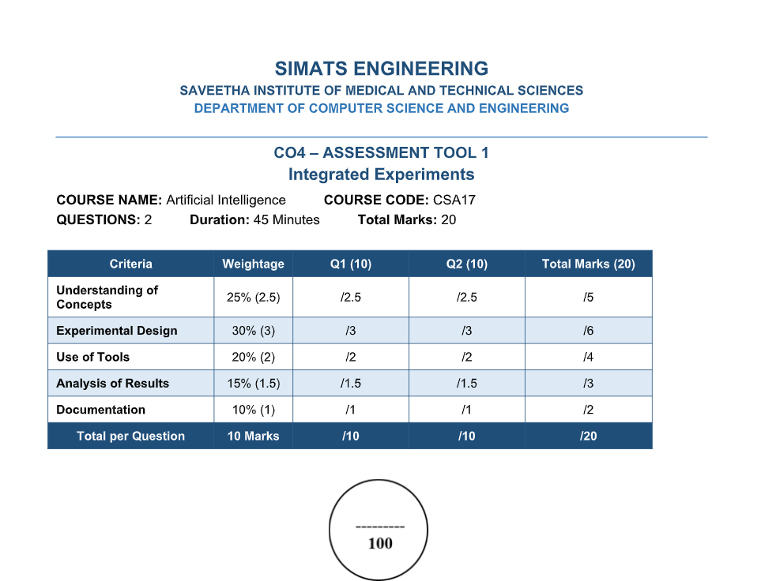
ANNEXURE A – ARTICLE REVIEW

ANSWERS:

Task 1: Article Summary
(a) Article Citation Details, Domain and ML Problem
Full citation: Hua Zheng, Jiahao Zhu, Wei Xie, and Judy Zhong, “Reinforcement learning assisted oxygen therapy for COVID-19 patients under intensive care,” BMC Medical Informatics and Decision Making, Volume 21, Article 350, 2021. DOI: 10.1186/s12911-021-01712-6.
Domain/Application Area: Healthcare, intensive care, COVID-19 respiratory support, and personalized oxygen therapy.
Specific ML Problem: The research addresses sequential treatment decision-making for critically ill COVID-19 patients who require oxygen therapy. The objective is to learn a personalized policy that recommends an oxygen flow rate based on the patient's current clinical state and aims to reduce 7-day mortality. The authors formulate the patient's evolving health condition and oxygen treatment as a Markov Decision Process and use Deep Deterministic Policy Gradient (DDPG), a deep reinforcement learning algorithm designed for continuous state and action spaces.
(b) Key Objective and Research Gap – 150–200 Words
The main objective of the article is to develop a personalized reinforcement learning system that can continuously recommend oxygen flow rates for critically ill COVID-19 patients. The authors identify that oxygen therapy is a sequential decision problem because the patient's condition changes over time and the effect of an oxygen decision may not be immediately observable. Conventional treatment is guided largely by clinical experience and current patient measurements, while an AI system can use historical electronic health records to learn relationships between patient state, treatment and long-term outcome. The research gap is the limited use of reinforcement learning for continuous oxygen-flow control under real clinical conditions, particularly when the action is continuous rather than a small set of discrete treatment choices. To address this gap, the authors formulate oxygen therapy as an MDP and apply DDPG to learn an optimal policy from retrospective EHR data. The learned policy recommends an individualized oxygen flow rate and is evaluated using leave-one-hospital-out validation and predicted 7-day mortality. The study therefore connects sequential AI decision-making with personalized intensive-care support.

Task 2: Methodology Analysis
(a) ML Technique and Dataset
The main technique is Deep Deterministic Policy Gradient (DDPG). DDPG is an actor-critic reinforcement learning algorithm suitable for continuous action spaces. In this study, the actor network produces an oxygen-flow recommendation and the critic network estimates the expected cumulative reward for a state-action pair. The authors use target networks and experience replay to improve learning stability.
The patient's clinical trajectory is represented as an MDP. The state contains demographic information, clinical characteristics, laboratory results and vital signs. The action is the oxygen flow rate, ranging from 0 to 60 L/min. The reward is linked to the patient's ultimate outcome: +15 for survival and −15 for death. A discount factor of 0.99 gives substantial importance to future outcomes.
Dataset: The study used retrospective electronic health records from New York University Langone Health. The cohort contained 1,362 COVID-19 patients with PCR-confirmed infection and oxygen therapy. Eligible patients were hospitalized adults aged 50 years or older, with data collected from March 2020 to January 2021. The study included demographic information, comorbidities, treatments, laboratory data and vital signs. Thirty-six laboratory tests were selected using criteria including less than 28% missing values and relevance to COVID-19 severity. The validation strategy divided the data by hospital and used leave-one-hospital-out validation: patients from three hospitals were used for training and the remaining hospital for validation in each simulation.
The paper states that the state included age, sex, race, smoking status, BMI, comorbidity diagnoses, 36 daily laboratory test values and six unique vital signs. The continuous action was the oxygen flow rate. The data were transformed into sequential state-action-next-state-reward experiences for reinforcement learning.
(b) Mapping to CO 4, Strength and Limitation
CO 4 Mapping:
Reinforcement Learning: DDPG learns an optimal treatment policy from patient trajectories.
Markov Decision Process: Patient health is represented as state, oxygen flow as action, survival/death as reward, and subsequent patient observations as transitions.
Inductive Learning: The agent learns a general treatment policy from historical patient experiences and applies it to unseen patient states.
Decision-Making: The learned policy selects a continuous treatment action that maximizes expected cumulative health reward.
Methodological strength: A major strength is the use of leave-one-hospital-out validation. This tests whether the learned policy can generalize beyond the hospital data used for training and is more informative than a random split alone. The use of a continuous-action algorithm is also well matched to the real oxygen-flow control problem.
Methodological limitation: The study is retrospective and observational. When the RL recommendation differs from actual physician treatment, the true outcome under the alternative treatment is not directly observed; therefore, the authors estimate outcomes using a Cox survival model. This introduces uncertainty and potential confounding. The authors also acknowledge that the cohort may not represent COVID-19 patients or oxygen practices in other populations.

Task 3: Results & Critical Evaluation
(a) Key Results
The study reports that the estimated 7-day mortality under physician-prescribed oxygen was 7.94% (95% CI: 7.41–8.47), whereas the estimated mortality under the RL-oxygen policy was 5.37% (95% CI: 4.94–5.80). This corresponds to a reduction of 2.57 percentage points (95% CI: 2.08–3.06; P < 0.001). The average oxygen flow recommended by RL was 1.28 L/min lower than the oxygen flow actually delivered by physicians (95% CI: 1.14–1.42).
The authors also report that the survival prediction model achieved cosine similarity greater than 99.9% and a concordance index of 0.83. A paired chi-squared test produced P < 0.0001, indicating no significant difference between predicted and observed survival in that validation analysis.
The RL policy was within 5 L/min of the physician-administered flow in 29% of measurement times and within 10 L/min in 44% of measurement times. The authors therefore describe the overall concordance as approximately 44%.

Comparative Results Table:
Measure | Physician/ObservedPractice | RL-Oxygen
Estimated 7-day mortality | 7.94% | 5.37%
Mortality difference | Reference | 2.57percentage-point reduction
Average oxygen flow | Reference | 1.28 L/min lower
Concordance within 10 L/min | Reference | 44%
Concordance within 5 L/min | Reference | 29%
Survival-model concordance index | — | 0.83
Cosine similarity of predicted vs observed survival | — | >99.9%
(b) Critical Evaluation
The reported results are promising, but they should not be interpreted as proof that RL oxygen therapy causes a reduction in mortality. The estimated mortality reduction is statistically significant and the confidence interval is relatively narrow, but the RL recommendation is evaluated using retrospective observational data. For cases where RL and physician decisions differ, the actual counterfactual outcome is unavailable and must be estimated. This makes causal interpretation more difficult.
Potential biases include selection bias because the cohort contains patients from a single health system, missing-data effects, and differences in treatment practice between hospitals. The authors themselves state that sample scarcity and a large proportion of missing values may increase uncertainty. Another concern is distribution shift: COVID-19 treatment protocols changed over time, so a policy learned from early-pandemic data may not generalize to later clinical practice.
Additional experiments that would strengthen the findings include prospective external validation at multiple hospitals, testing on later pandemic periods and different geographic populations, calibration and subgroup fairness analysis, sensitivity analysis for missing data, comparison with additional RL algorithms, and ultimately a carefully controlled prospective clinical trial. A safety-constrained RL experiment would also be valuable so that oxygen recommendations are explicitly bounded by clinical guidelines.
(c) Real-World Applicability
The technique could be deployed as a clinical decision-support system in ICUs for patients requiring supplemental oxygen. It could continuously process vital signs and laboratory information and provide an individualized oxygen-flow recommendation to clinicians.
Industry scaling challenges include availability of high-quality longitudinal EHR data, interoperability between hospital systems, computational requirements for real-time inference, monitoring of model drift, cybersecurity, patient privacy and integration with medical devices. Ethical challenges are especially important because a treatment recommendation can directly affect patient safety. The system should therefore provide clinician oversight, clear audit trails, safety constraints, and validation before clinical deployment.

Task 4: Reflection & Learning Outcome
(a) Three Key Insights and CO 4 Connections
Insight 1 – Reinforcement Learning is suitable for sequential medical decisions: I learned that treatment selection cannot always be treated as a one-time classification problem. In the article, oxygen flow at one time affects future patient states and outcomes. This deepens the CO 4 concept of Reinforcement Learning because the agent learns a policy that maximizes cumulative future reward rather than only immediate prediction accuracy.
Insight 2 – MDP components provide a practical representation of healthcare decision-making: The article clearly maps patient information to state, oxygen flow to action, survival outcome to reward, and future observations to state transitions. This connects directly to the CO 4 syllabus concept of Markov Decision Processes and shows how an abstract AI framework can represent a real clinical problem.
Insight 3 – Continuous-action RL requires a different algorithmic approach: Oxygen flow is a continuous quantity from 0 to 60 L/min, so a discrete-action Q-learning approach would not naturally represent the complete action space. The use of DDPG demonstrates why actor-critic methods are useful for continuous control. This connects CO 4 Reinforcement Learning with policy learning, Q-function approximation and action optimization.
(b) Proposed Novel Experiment / Enhancement
A useful extension would be to develop a safety-constrained multi-hospital offline reinforcement learning system. The new experiment could combine the existing DDPG-style policy with explicit clinical constraints on oxygen flow, minimum/maximum safe rates and patient-specific contraindications. The model could then be evaluated on independent hospitals from different regions and on a later time period.
This enhancement is feasible because the original study already uses EHR-based state information, hospital-level validation and a continuous oxygen-flow action. The main additional requirement would be access to external de-identified datasets and a clinically reviewed set of safety constraints. The expected impact is improved generalisation, safer recommendations and stronger evidence that the learned policy is not simply adapting to one hospital's treatment practices. The experiment would also make the system more suitable for eventual clinical decision-support deployment.
Overall Review and Conclusion
This article demonstrates a strong application of Artificial Intelligence and Reinforcement Learning to a real healthcare problem. The use of DDPG is appropriate because oxygen flow is continuous and patient health evolves over time. The study's large clinical feature set, sequential MDP formulation and leave-one-hospital-out validation are important strengths. The reported results suggest that the learned policy could reduce estimated 7-day mortality while recommending lower average oxygen flow. However, the retrospective nature of the study, counterfactual estimation, missing data and limited population representativeness prevent the results from being considered definitive clinical evidence. Overall, the article provides a clear practical connection to CO 4 concepts and demonstrates how reinforcement learning can support personalized, sequential decision-making in healthcare, provided that safety, validation, fairness and clinician oversight are maintained.
Article Reference
Zheng, H., Zhu, J., Xie, W., & Zhong, J. (2021). Reinforcement learning assisted oxygen therapy for COVID-19 patients under intensive care. BMC Medical Informatics and Decision Making, 21, 350. https://doi.org/10.1186/s12911-021-01712-6

